## Create AWS Security Credentials

Execute the following steps to create the AWS security credentials required to enable video streaming:

* 1. Login to the AWS kinesis portal: <https://us-east-1.console.aws.amazon.com/kinesisvideo/home?region=us-east-1#/dashboard>

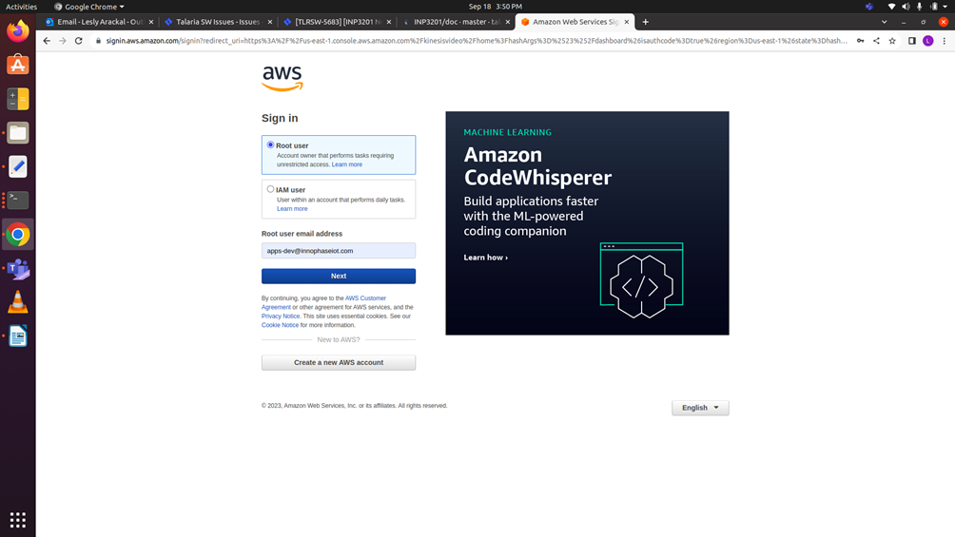

Figure 17: Login to AWS kinesis portal

* 1. Create a user group.

Figure 18: Create user group

* 1. Click on Create user.

Figure 19: Create user

* 1. Provide the new user name and click on Next.

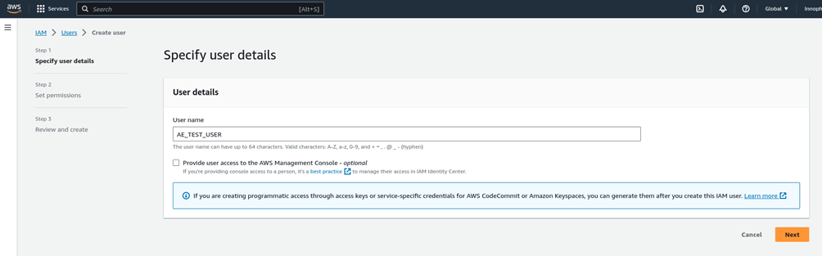

Figure 20: Enter user name

* 1. Add the user to the user group created in step 2 and click Next. Ensure to provide access to the video streaming resources in the policy. For example:

|  |
| --- |
| {  "Version": "2012-10-17",  "Statement": [  {  "Effect": "Allow",  "Action": "*",  "Resource": "*"  }  ]  } |

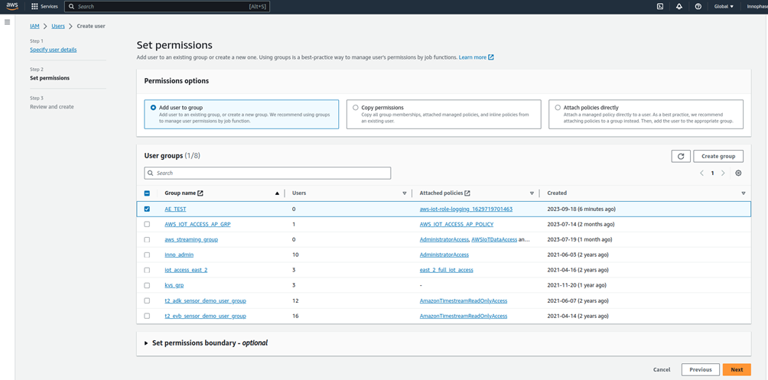

Figure 21: Extend permissions

* 1. Select the user created previously and click on Create access key.

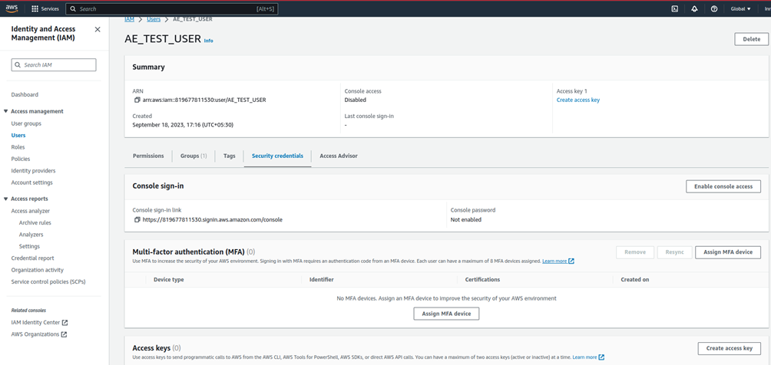

Figure 22: Create access key for the user

* 1. Select the option Application running on an AWS compute service, check the confirmation box and click Next.

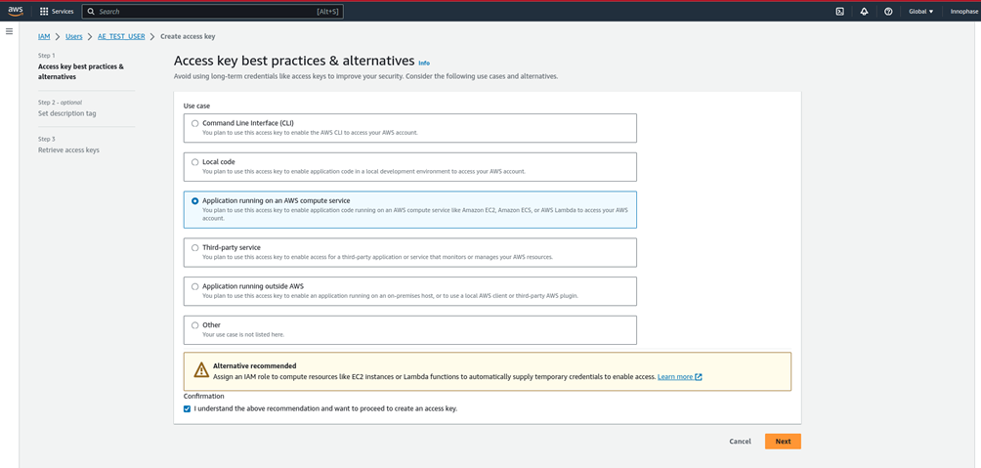

Figure 23: Application running on AWS compute service

* 1. Click on Create access key.

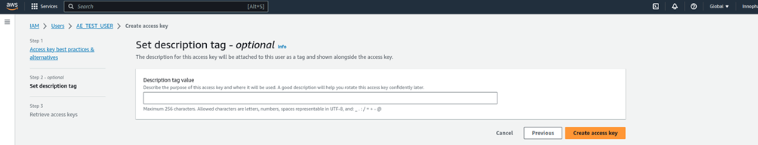

Figure 24: Create access key

* 1. Copy the generated access key, secret access key and click Done.

 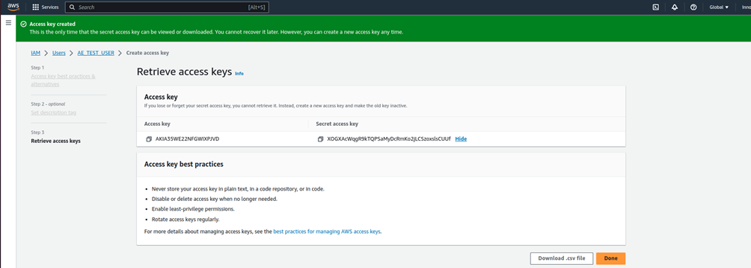

Figure 25: Access and secret access key

* 1. Click on the Kinesis Video Streams (search for Kinesis Video Streams in the search bar).

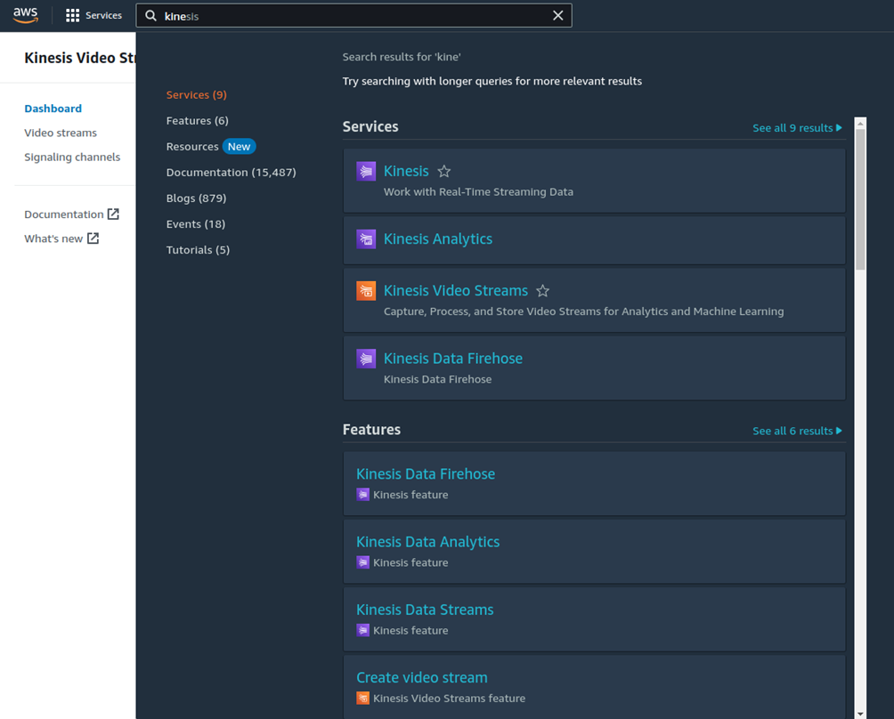

Figure 26: Kinesis video streams

* 1. Click on Create signaling channel.

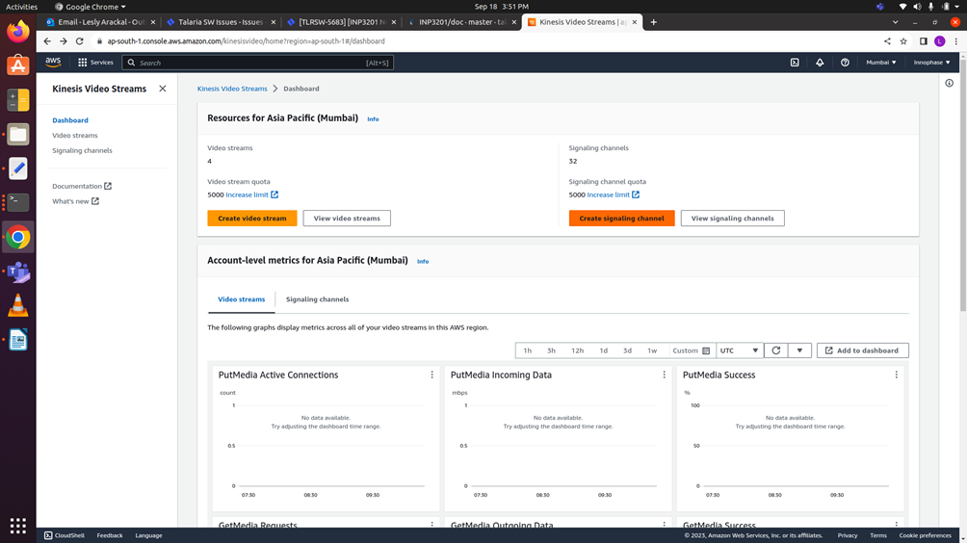

Figure 27: Create signaling channel

* 1. Provide a name to the new signaling channel and click on Create signaling channel.

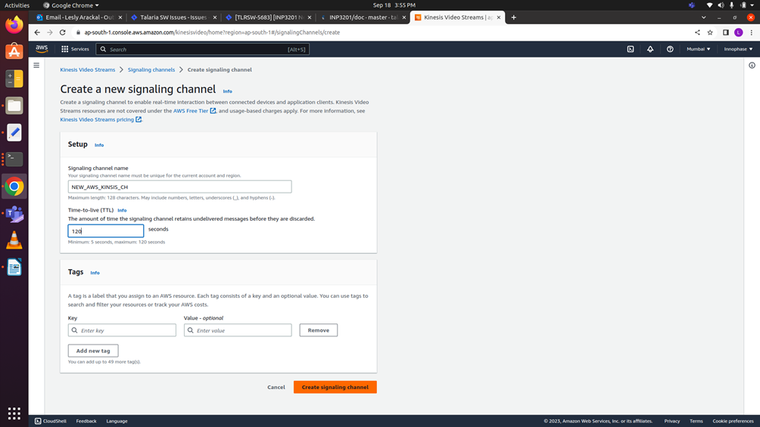

Figure 28: Enter signaling channel name

* 1. A new signaling channel will be created. Copy the Signaling channel ARN.

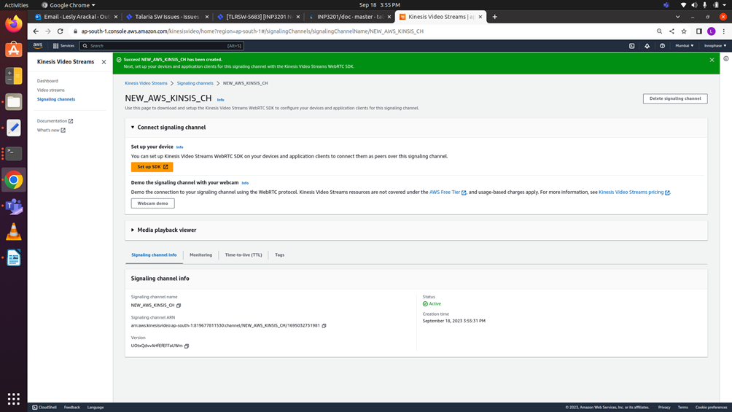

Figure 29: Signaling channel ARN

* 1. Upon successfully initiating video streaming from the Host, video streaming will be available under Media player viewer.